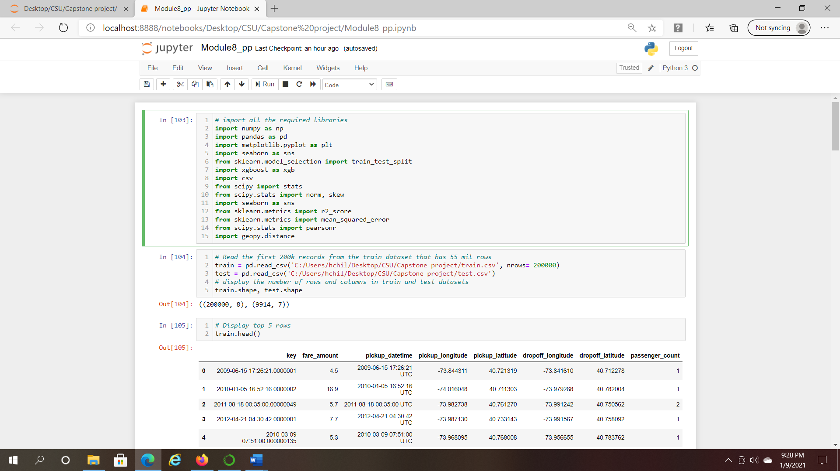

*Figure 1.* Read the dataset and display the data

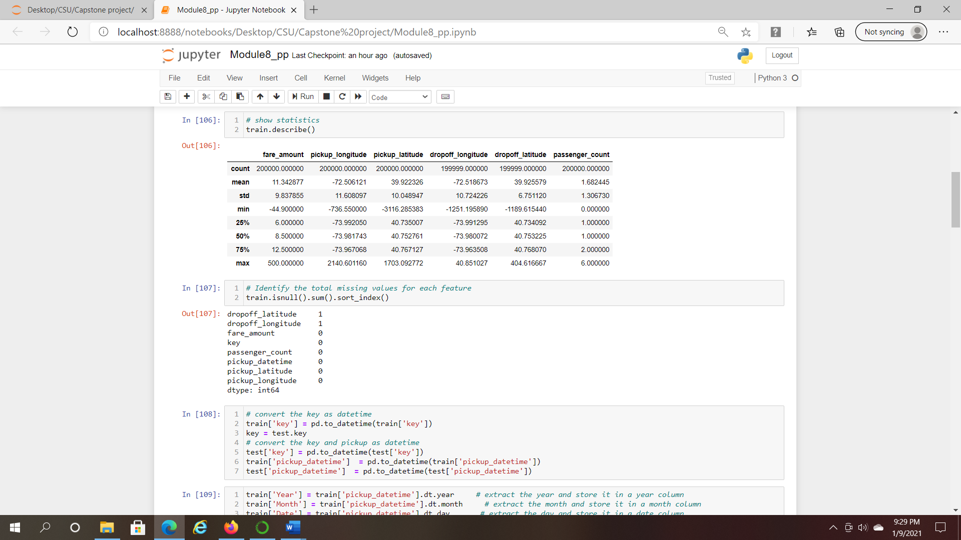

*Figure 2.* describe the Statistics

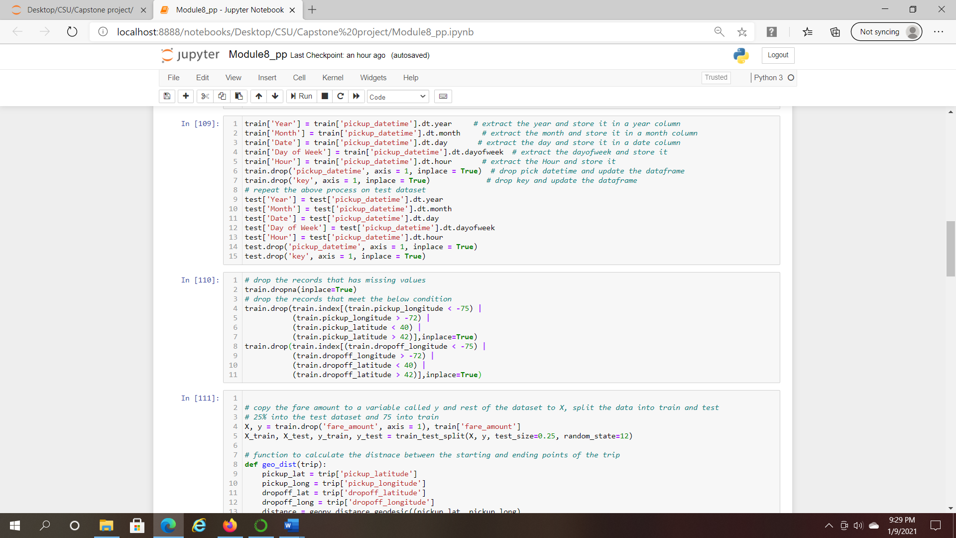

*Figure 3.* Transform the data and calculate the distance

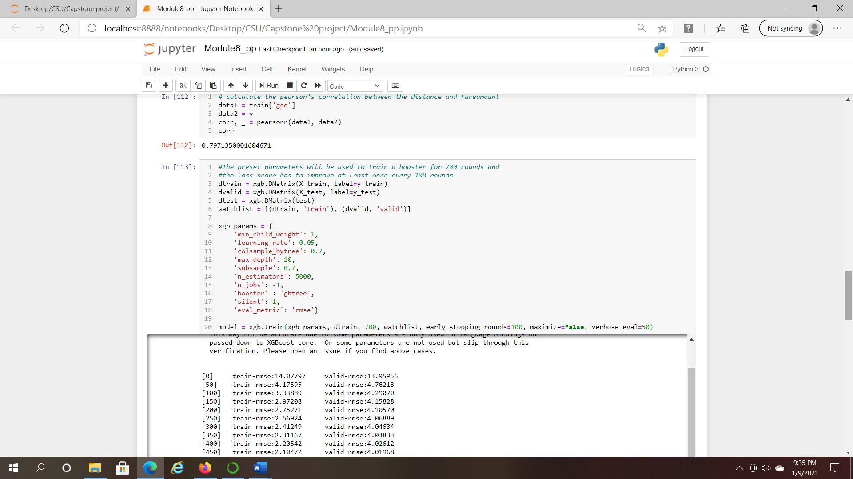

*Figure 4.* Pearson Correlation and XGBoost output

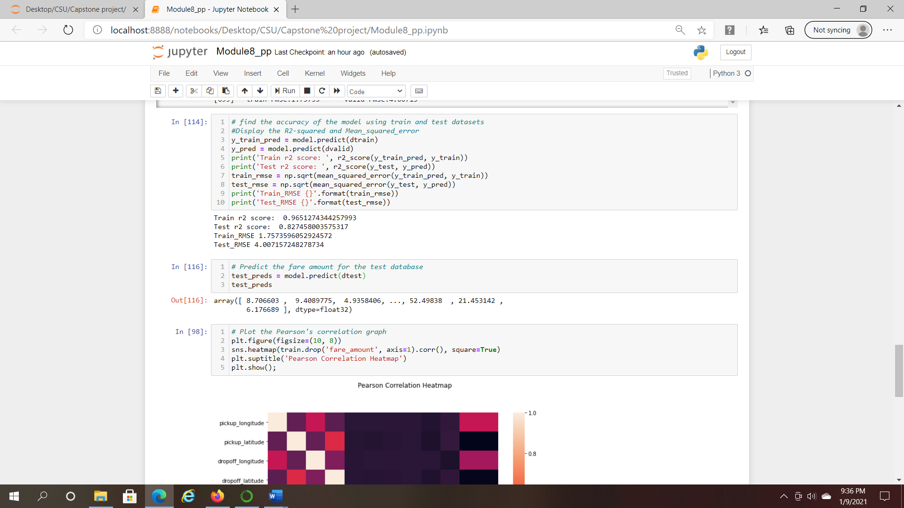

*Figure 5.* display R2 Squared and RMSE

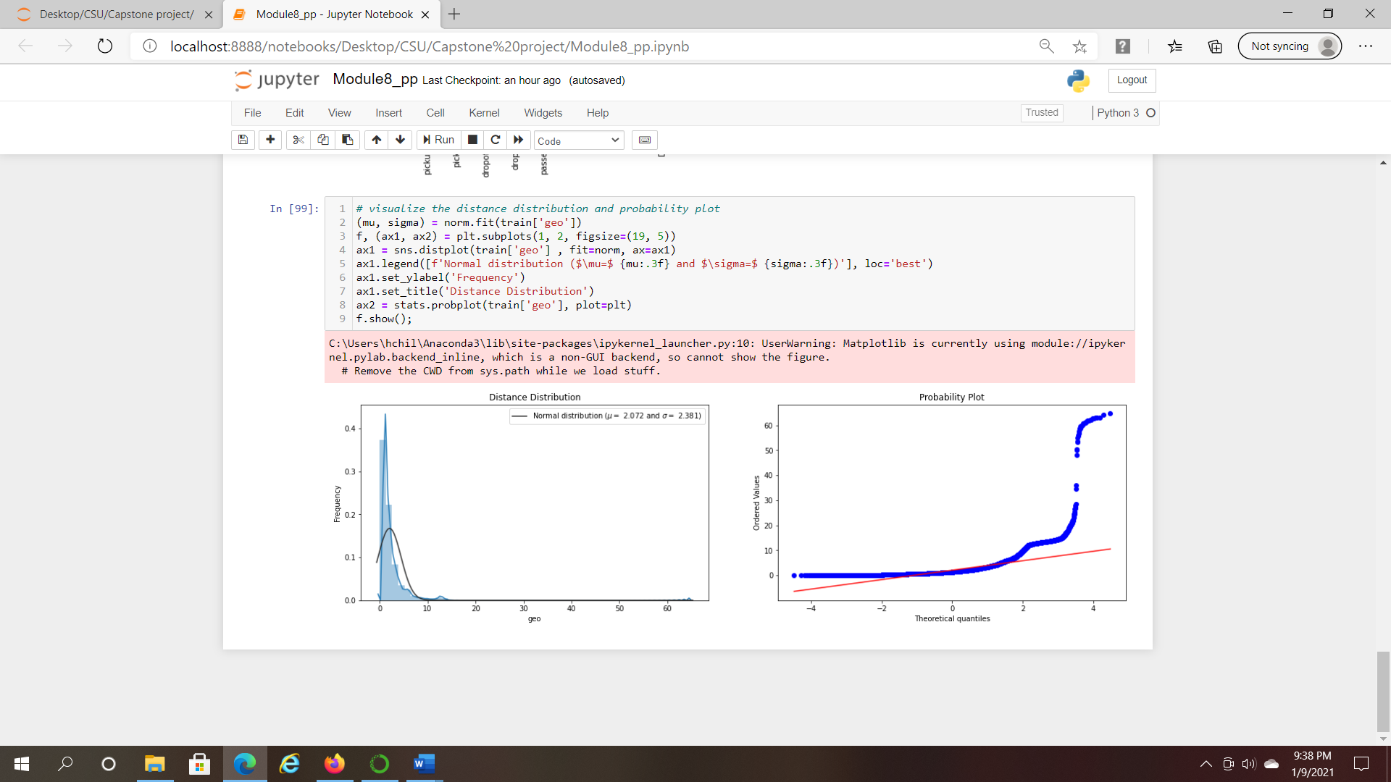

*Figure 6.* Data Visualizations